Name: _____Huang Yuebin_____ ( 11 ) Date: _22/2/22_

**PROJECT PART 1 (Planning) 25 Marks (15% of overall)**

**Date issued: T1W4 (Week of 24th Jan) Date Due: T1W8 25th Feb 2022, 2100hrs**

**Academic Integrity**

ALL codes will be thoroughly checked and compared for any plagiarism. Any act of dishonesty will render zero mark for originator group and the “copy-cat” group. You should do the assignment on your own (i.e. the assignment must be your original work). Have pride in your own work. You will feel good if it is your own work

**Late Work**

**10% of total assignment marks will be deducted per week you are late.**

Should you need extension due to **valid reasons**, please alert and negotiate with teacher early (Extension request the day before deadline or on the due date itself will NOT be accepted). Please plan your time wisely.

**INSTRUCTIONS**

* You are required to submit:
  + This exact word document, where all the blanks are completed.
  + Rename the document: **ProjectP1_*<Your name>*.pdf** (Convert the given document to PDF before submission)
* Students who fail to adhere to submission requirements will have their Project Part 1 marks deducted accordingly.
* Marks will be deducted for sloppy / no effort work. Things to look out for includes:
* All tasks are properly crafted and are, at least, **close to realistic and original**
* Lo-Fi / Hi-Fi prototypes are properly done and dimensions of the phone frames used to draw the prototypes are consistent
* Iconography, typography and colour schemes all make sense and will be beneficial to the user experience
* Note that the tasks should be done sequentially, and it is advised that you put in the due time and effort in this part as it will help you have a better idea and understanding of what your final product will require.

**Task Description:**

In every development project (regardless whether it is mobile software or not), in a professional setting, planning for your project is important to ensure that your new product is:

* Competitive in the market
* Is user-friendly and promotes a positive user-experience
* Appeals to as diverse an audience as possible, taking into account any members of your main target audience who many have certain accessibility issues.

Part 1 of the project applies the UX design thinking process in helping you decide on the initial project idea and at the same time, improve on your idea to ensure that your app fits the criteria for the new product as described above.

**Task 1: Deciding on your project idea and target audience**

In the box below, you will describe your project idea and target audience.

Outline:

* What is the idea of your app and who is your target audience?
* What are some of the main functionalities of your app?
* How do you think your app’s main functionalities can benefit your target audience?
* Project timeline which shows it can realistically be completely developed and submitted before T2W3 (Part 2 deadline)
* Set some reasonable success criterion to determine if creation of your app is successful (note that T2W4 and T2W5 is the app showcase / user feedback session)

|  |
| --- |
| Idea of app: Diary  Main functionalities:   1. Note-taking of the day (can be labeled under subject codes, or be under diary for ease of searching) (user can have basic drawing and typing functionalities) 2. Password protected (User sets a password that can be changed to protect content of the diary) 3. To-Do List (Homework or items that are due on a certain day appears on the diary page as a sticky note that can be checked off) 4. Timetable (for work or for school) (Appears on page as a set of sticky notes to write about what they experienced or learnt in the certain time periods)   Benefits:   1. Note taking can have a diverse usage, from noting down your darkest secrets to beautiful cursive and colorful notes for your PC4131 end-of-year exams. 2. Password to enter the app allows for privacy of sensitive content 3. To-Do list allows for better organization of work and deadlines 4. Timetable allows for better time management   Project timeline   1. Start part one 3 days before part one deadline 2. Implement proposed functionalities in order that is listed during march holidays    1. Basic UI and minimal functionalities should be implemented at least 3. Improve UI and add features to functionalities during march holidays 4. Polish app (if possible) during T2W1 and T2W2 5. Submit an excellent app on T3W3   Criteria   1. Not painful to look at / Pleasing to the eye 2. All or at least most of the functionalities work well 3. No unreasonable crashes of the app 4. New user finds the app intuitive to use (able to use all/most functionalities without guidance) |

**Task 2: Internet market research on competitiveness**

Has my app idea been done before? (Circle the answer): YES / ~~NO~~

If yes, how will you make your app stand out and unique from what is out there in the market?

Else if no, based on your findings, why has such an idea not been done yet?

|  |
| --- |
| There has been similar apps that have parts of the functionalities I have mentioned, but I have not encountered an app that can perform everything I have listed out as a functionality as these functionalities proposed are a result of features I find lacking in popular to-do apps and diary apps  The way my app can stand out is how each functionality is integrated with one another.   * To-do list is connected to timetable, where listed items can appear under that subject’s slot in the timetable. List items can be tagged with multiple tags, much like roles in discord servers allowing them to be filtered/sorted by tags. * Note-taking and diary jotting can also be tagged with subject codes as tags to be filtered and for collation. * Items on to-do list appear on that day’s diary page as an item that can be checked off. |

**Task 3: Creation of Personas**

Create 3 personas which are potential members of your target audience. Note that your personas should represent distinct categories of users of your app, and can be differentiated by: Age, Career, Abilities / Disabilities, Gender, Level of Ability with Technology, Current Goals / Challenges.

Note that your personas need to be as realistic as possible and should ideally be based on real people you have met and interviewed / had a conversation with.

**Persona 1 (Fill in the blanks in the light blue boxes)**

|  |  |  |  |
| --- | --- | --- | --- |
| Name (Age): | Aaron Ngo (29) |  | |
| Occupation: | Engineer |
| Hobbies: | Playing badminton / reading |
| Description about myself: | I enjoy my kids. It brings me joy every Sunday when I bring them to the park to play badminton. In my free time I like to read or spend time with my wonderful wife. | Personality (observed by you) | Patient and caring. Always lends a helping hand to those in need. |
| 3 current goals & motivations | 1) Raise my kids to become successful members of society  2) Get a pay raise so that I can bring the kids to LEGOLAND next year  3) Ensure my family lives a comfortable and happy life in a safe home. | 3 frustrations / challenges | 1) Poor time management  2) Kids sometimes forgets to do homework  3) Keeping track of all the household duties and work responsibilities is difficult |

**Persona 2 (Fill in the blanks in the light blue boxes)**

|  |  |  |  |
| --- | --- | --- | --- |
| Name (Age): | Tyson Ngo | Young Asian Boy Over White Background, Be Upset; Have a Bad Temper  Emotional Stock Photo - Image of crazy, frustrated: 146524772 | |
| Occupation: | Student |
| Hobbies: | Badminton, gaming |
| Description about myself: | I play a lot of VALORANT and is in the top 1% of SEA players. School feels “meh” and I’d rather stay at home to play more games. Mediocre at badminton | Personality (observed by you) | Witty, thoughtful, and irresponsible |
| 3 current goals & motivations | 1) Reach top 500 players rank in SEA in VALORANT  2) Enjoy my youth  3) Get good grades | 3 frustrations / challenges | 1) Forgets to do homework frequently  2) Sleeps very late because I have a poor awareness of how much I game.  3) Struggling in school, specifically chemistry. |

**Persona 3 (Fill in the blanks in the light blue boxes)**

|  |  |  |  |
| --- | --- | --- | --- |
| Name (Age): | Lisbeth Alexandra |  | |
| Occupation: | Retired, Ex-Marine Corps |
| Hobbies: | Playing chess, long walks on the beach |
| Description about myself: | I love playing chess and going for chess tournaments. My favorite chess piece is the queen. I love my family dearly and look forward to seeing them every Sunday. As I am diagnosed with Alzheimer’s (could be due to collateral damage from serving the nation), I have trouble remembering important dates and stuff. | Personality (observed by you) | Cheerful, outgoing, and especially doting of her grandchildren |
| 3 current goals & motivations | 1) Live past the age of 100  2) Become a chess grandmaster  3) Watch and nurture my grandchildren to grow to be wonderful people. | 3 frustrations / challenges | 1) Forgetful, especially when it comes to attending chess tournaments and of what has happened in the past (like the day before). Likely due to my Alzheimer’s condition.  2) Difficult to connect with grandchildren due to the generational gap between us, where we grew up in different worlds.  3) Have not improved chess ELO rating in the last 3 years. |

**Task 4: User stories**

Based on the personas you have developed in Task 3, craft the user stories. They could be based either on the actual interviews / conversations with people you have used for your personas, or more of a thought experiment if your persona, with his/her characteristics, used your app.

Recall the user story template given in the notes:

|  |
| --- |
| *<Name of user from persona>* **is a / an** *<type of user based on characteristics in persona>*.  **He / She wants to** *<tasks / frustrations / challenges to be addressed>* **so that** *<the user’s own success criteria for the app based on tasks / frustrations / challenges>*  **Scenario A:** *<Contextual requirements the app should fulfill>*  Given that *<some context that app is used>***, when** *<some action is done on the app>***, then** *<expected outcomes app must meet>*  **Notes:** *<Any notes or findings you may want to add from research or persona characteristics>*  **Priority:** *<High / Medium / Low / Unprioritized>* |

Note that each user can have more than 1 challenge which needs to be addressed, and within each challenge, there should only be 1 scenario. Keep the number of challenges for each persona to a maximum of three per persona (and a minimum of one per persona). Note that the challenges and scenarios need to be realistic, and make your own assessment of how high of a priority should the challenge be addressed by your app, which will be useful in the development phase later.

**User story (Persona 1):**

|  |
| --- |
| *Aaron* **is a** *working adult with family and work responsibilities*.  **He / She wants to** solve his poor time management problems and keep track of tasks**so that** he can spend more quality time with his family members by going to play badminton with them. This also allows him to have more free time to read and relax instead of keeping all of the tasks due in his head to remember.  **Scenario A:** Boss just informed him of multiple meetings and tasks due at the end of the week on Friday  Given that Aaron wants to spend more time with his family playing badminton on Thursday afternoon and already has a headache keeping track of all the work due on Friday, he is worried about not being able to play badminton with his family**, when** he uses the app to note down the tasks he has due and the timings of the meetings he has to attend**, then** he is able to manage his work better and depend less on his memory to keep track of tasks due, thus freeing up both his time and mind to have an enjoyable afternoon with his family.  **Notes:** If Aaron finds this app useful, he might introduce it to his son Tyson as he finds that lately Tyson has slept quite late and can optimize his time better using the app. Like father like son.  **Priority:** *<***High** */ ~~Medium~~ / ~~Low~~ / ~~Unprioritized~~>* |

**User story (Persona 2):**

|  |
| --- |
| *Tyson* **is an** irresponsible student / teenager.  **He / She wants to** complete his homework on time and sleep at a reasonable hour**so that** he can improve his grades and maintain his parents’ trust in him and thus be able to play more video games.  **Scenario A:** Tyson’s grades are dropping  Given that he has not been managing his time well and fails to prioritize work over play**, when** he organizes homework as tasks in the app, he can see how doomed he is if he procrastinates any further**, then** be more productive and finish homework on time, thus improving learning and subsequently improves his grades  **Notes:** *This phenomenon of playing games to procrastinate work appears to be quite a common sight*  **Priority:** *<****High*** */ ~~Medium~~ / ~~Low~~ / ~~Unprioritized~~>* |

**User story (Persona 3):**

|  |
| --- |
| *Lisbeth* **is a** retiredelderly who is diagnosed with Alzheimer’s.  **He / She wants to** be more independent in taking medicines and going to chess tournaments**so that** she can be less reliant on her family members to remind her of life’s simple daily tasks, which lets them worry less about her health.  **Scenario A:** Lisbeth’s family has had to remind her of recent events that occurred, which much to Lisbeth’s frustration she does not remember of such events happening.  Given that Lisbeth has a poor memory (possibly due to her Alzheimer’s condition)**, when** she writes down her daily activities and interesting events as diary entries in the app**, then** she can have a digital record of her activities and doubt herself lesser.  **Notes:** *Alzheimer’s disease does not affect motor skills until the later stages, so Lisbeth should have no problem opening the app to view its content and update it unless her condition deproves.*  **Priority:** *<~~High~~ /* **Medium** */ ~~Low~~ / ~~Unprioritized~~>* |

**Task 5: Consolidation of required features of app**

After the user stories are completed, you will have to consolidate your user stories and determine the required features of your app. Note that the required features may include either your original ideas, modifications of your original ideas after going through the user stories or additional features from your findings doing the previous few tasks. The features should be sorted by priority. (High / Medium / Low / Unprioritised)

|  |  |  |
| --- | --- | --- |
| Features / Functionalities | Why feature is needed? | Priority level |
| To-do list able to add a priority level tag | To allow users to prioritize work according to how important it is | High |
| To-do list able to set tasks as recurring task | Easier to set events such as birthdays, grocery shopping | High |
| Camera function to take pictures to be added into diary / to-do list | Users with poor memory can benefit from having photo evidence of what they did in the past to remind them of tasks. | High |
| Calendar view of events and tasks from to-do-list | More user-friendly design to give a bird’s eye view of the future | Medium |
| Set mini-tasks and due dates within a task | To split up a big project into smaller parts to be completed by a certain time period | Medium |
| Password protection (PIN / biometric fingerprint) | Increases privacy and security of diary.  Can be turned on/off for certain pages of the diary. | Medium |
| Timetable | To help students and working adults organize their time better | Low |

**Task 6: Lo-Fi / Hi-Fi Prototype of your app**

By right, there should a storyboarding component featuring the user interaction with the app but that will be combined with creation of the low-fidelity (lo-fi) / high-fidelity (hi-fi) prototype.

Based on Task 5, you are to create a screen-by-screen prototype featuring the how your app will look like for each screen your user will see. You can either do a:

* Lo-Fi Prototype (hand / digitally drawn sketches) WITH a sub-section detailing the actual icons, typography, images and colour schemes you will use for your app

OR

* Hi-Fi Prototype which will be the actual (or close to actual) screens of the final product which has all the actual icons, typography, images and colours all inside.

In your lo-fi / hi-fi prototype, you are to include:

* Point-form description of what the screen is supposed to show / expected user interaction (login to app, onboarding, capturing of user data, browsing of catalog, etc)
* Navigation arrows. These navigation arrows are supposed to start from the source button / link from one screen and lead to its supposed destination screen.
* If the screen is such that it navigates to different screens based on user input, you are to show the destination screens of each of the cases, with a point-form description of what is the case that will trigger that destination.

You are allowed to use the remaining blank space in this and the next page to do your lo-fi / hi-fi prototype or if it will be handdrawn, scanned and copy-pasted into this document (ensure that the scan is clear).

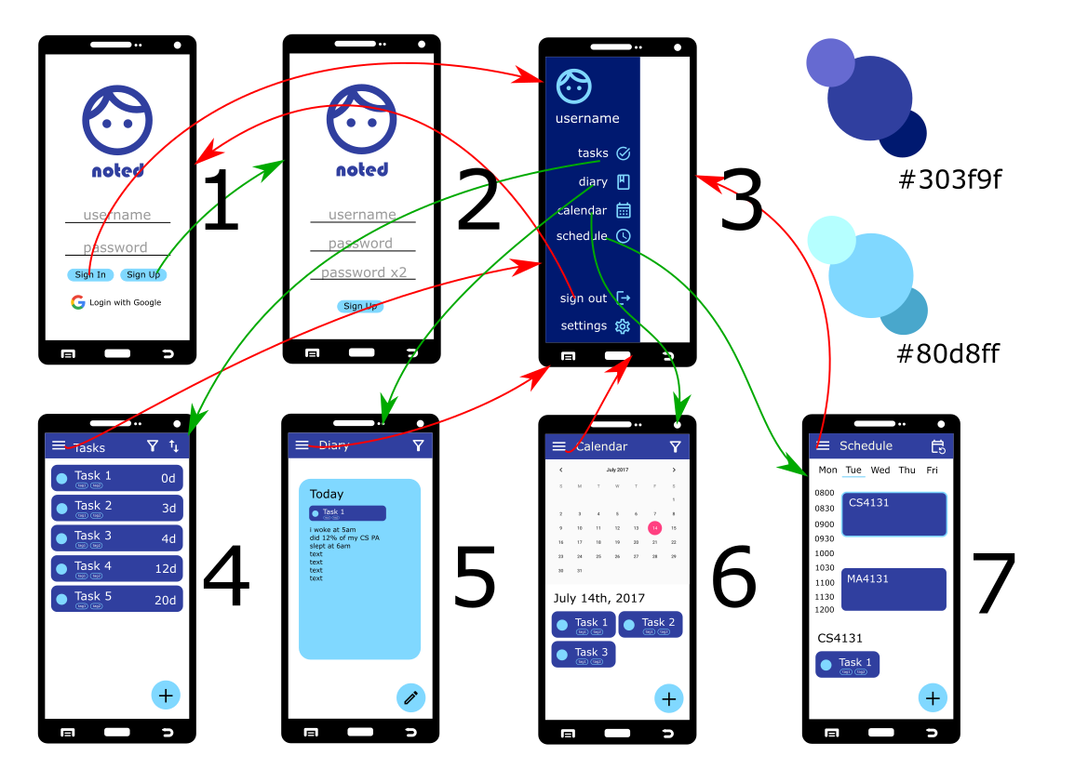

1. Login
   1. User can choose to login using a Noted account or link to Google account.
   2. User can also sign up as a new Noted user
   3. Logo will be replaced by an actual Noted logo in near future, the current logo is a standby logo
2. Sign up
   1. Like SuperVend, the user can enter a username and set a password.
   2. Logo will also be replaced by a real logo
3. Menu
   1. After signup, user will be brought to a menu page. Menu page allows users to navigate to
      1. Tasks
      2. Diary
      3. Calendar
      4. Schedule
      5. Sign out
      6. Settings
   2. Image will be user’s profile picture, controlled by the Google account or by account settings. Username will be the user’s username.
   3. Menu will be overlayed on top of the current activity
   4. Default activity is tasks activity (this activity is opened when the application starts)
   5. Menu button present on all activities to allow users to switch in between activities with ease
4. Tasks
   1. Filter action button
      1. Filters tasks by the tags they have
   2. Sorting action button
      1. Sorts tasks by due date / creation date / tags
   3. Card layout of tasks to be completed
      1. Tasks can be marked as completed on the indicator on the left of the card. Task name is shown in the card, as well as the tags the task has. Number of days left until the task is due is shown on the right side.
      2. Swiping card to the left deletes the task
      3. Swiping card to the right marks the task as completed
      4. Clicking on card shows the task expanded in a new activity, including details of the task and subtasks. Users can edit due date and other task details in this activity
   4. Plus FAB
      1. Opens new activity similar to expanding a task, allows user to add task name, due date, recurrence of task and attach tags to task.
5. Diary
   1. Filter action button
      1. Filters diary entries according to happiness of the day (rating given by user when writing diary entry), or day of the week. Allows user to view diary entries with smaller Cardviews
   2. Default Cardview size is the current one, allows user to see more details of the current diary entry.
   3. Swipe left and right to view previous diary entries
   4. Edit FAB
      1. Enters a new activity with details from the diary entry currently selected.
      2. Allows user to edit diary entry with text, tasks, or drawings
   5. Diary entry is inclusive of date, optional title, main text and rating
6. Calendar
   1. Filter action button
      1. Highlights days with a assignments inclusive of a certain tag, or days where the timetable includes such a tag
   2. Calendar view
      1. Allows user to select a date to view closer and with greater detail.
      2. If possible to implement, small color-coded dots appear under each date to symbolize certain tags.
   3. Date details
      1. Shows tasks due on the day, and if there is a diary entry, rating of the day will be shown as well.
   4. Plus FAB
      1. Works the same as the Plus FAB from tasks, allows user to add a new task on that selected date.
7. Schedule
   1. Repeat Schedule action button
      1. User can set the schedule to repeat after a day, a week, or 2 weeks based on their timetable.
   2. TabLayout (unless there is a better option) of days of the week
      1. Allows user to see schedule of the day in greater detail in spite of the limited screen size of mobile phones
      2. Tasks are shown under their tagged subjects / events. If no tag and conflicts with another subject/event, the task is treated as an “event” and shares the horizontal space with the other event(s)
   3. Selected subject/event will show all tasks from that corresponding tag under the schedule.
   4. Plus FAB
      1. Works the same as the Plus FAB from tasks, allows user to add a new task to that day of the week.

**Grading:**

|  |  |  |
| --- | --- | --- |
| **Tasks** | **Details of Requirements** | **Marks** |
| **Deciding on your project idea and target audience** | * Idea of app, functionalities and target audience are well-thought through and sufficiently novel * Project timeline is realistic and not too ambitious, neither is it too generous such that a lot of time is given for doing something not that challenging * Success criterions are realistic and measurable | 3 |
| **Internet market research on competitiveness** | * Competitive market research shows evidence of a rigorous enough research done * Critical yet creative insight on what can be done differently / why idea has not been done yet. | 2 |
| **Creation of Personas** | * All three personas are realistic * Each of the three personas represent distinct categories of the intended target audience * The personas taken together represent a diversified representation of the target audience | 4 |
| **User stories** | * All three user stories are realistic in the depiction of possible issues in the app usage * User stories outline the intention of the given template (highlighting challenges and a realistic scenario of the challenge) * Notes / priority section of the user stories show good critical insight on the challenges / scenarios faced in the user stories | 4 |
| **Consolidation of required features of app** | * Functionalities listed realistic and can be met with the app * Functionalities listed show evident reflection and critical thought into the previous tasks * At least 2 high priority, 1 medium priority and 1 low priority functionality stated with reasonable justification of functionality | 2 |
| **Lo-Fi / Hi-Fi Prototype of your app** | * Prototype is “drawn” on a consistent phone frame (equally sized) * Prototype shows that app is sufficiently complex (at least 6 screens) but yet, realistic for development * Individual screens are detailed in terms of the layout and UI components which are intended * UI components in the individual screens are not cluttered * Navigation arrows clearly show the source component and the destination screen * Point-form descriptions detailing the intended / expected user interaction with the screen are present and give a clear idea of how the UI interacts with the user. * Iconography, typography, images and colour schemes make sense and is beneficial to the user experience, while considering accessibility for the not so able, physically and technologically | 10 |